PAYROLL PROCESSING SYSTEM:

CREATE A SIMPLE CLOUD SOFTWARE APPLICATION FOR PAYROLL PROCESSING SYSTEM USING ANY CLOUD SERVICE PROVIDER TO DEMONSTRATE Saas INCLUDE THE NECESSARY FIELDS SUCH AS NAME OF EMPLOYEE,TA,HRA,NET PAY ,GROSS PAY:

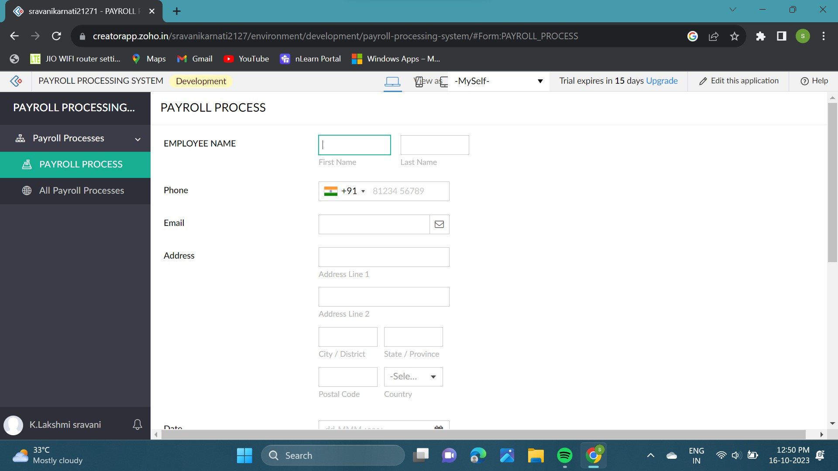

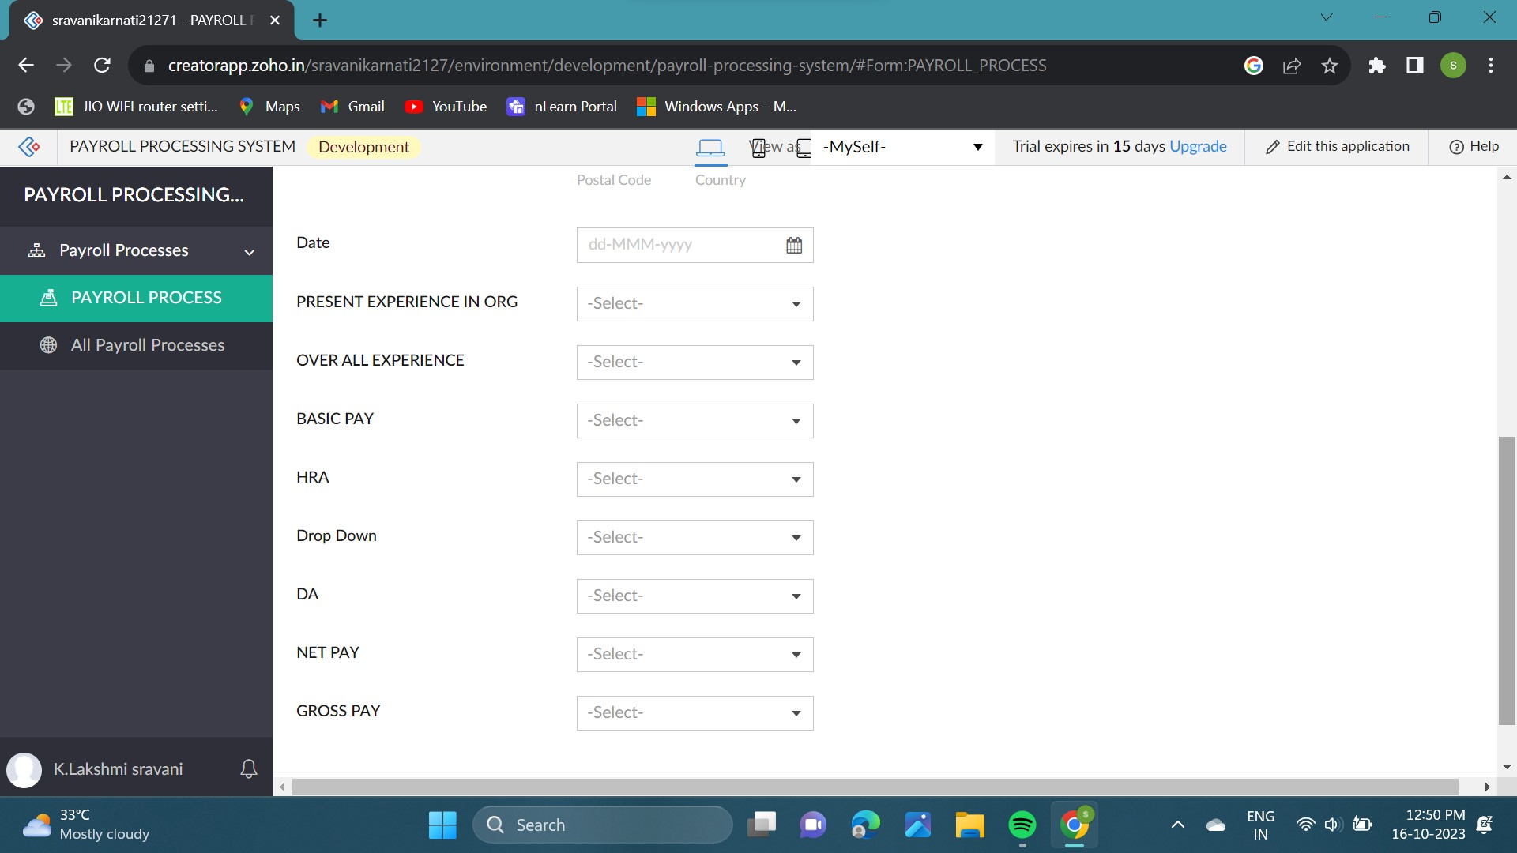

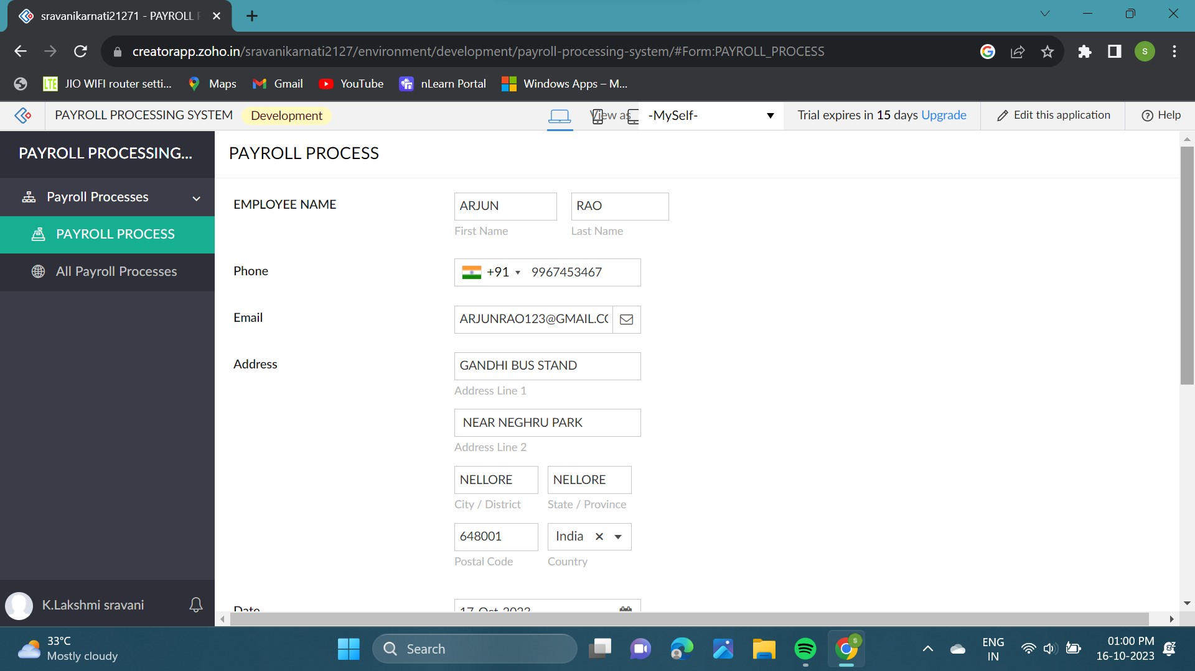

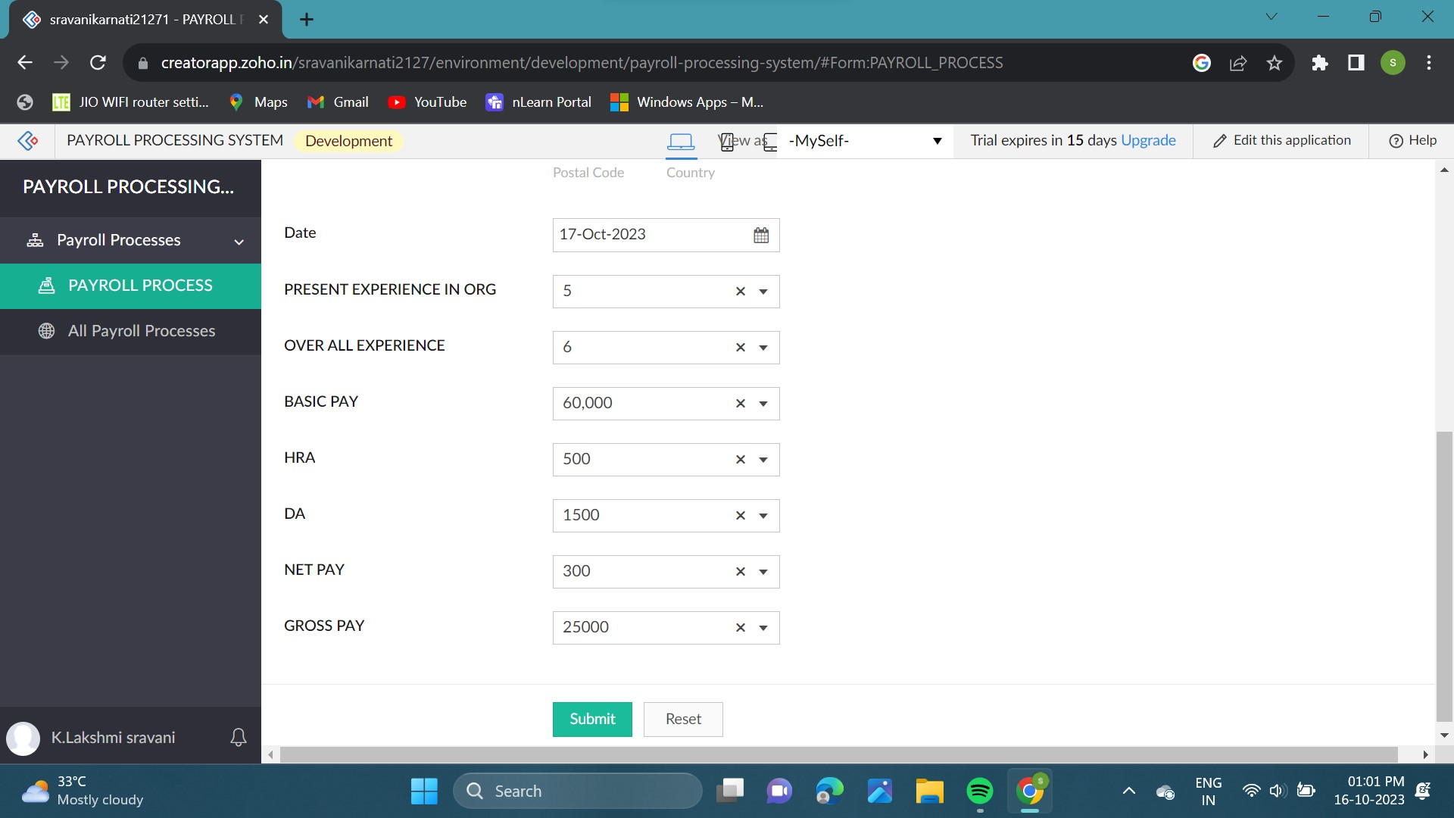

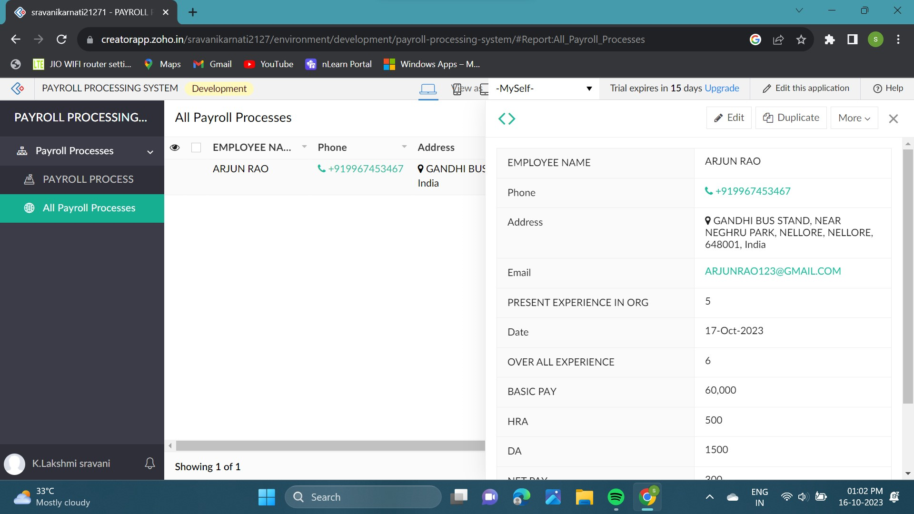

TRANSACTION PROCESS:

